**Words: 1,544**

**Sustainable Rural Development in the**

**Apuseni Mountains, Romania**

Paul Markowitz and James Gruber

**Prologue**

The Sustainable Rural Development initiative in the Apuseni Region of Romania[1] is an excellent example of the benefits of adaptive leadership. The initiative to bring about effective environmental change and sustainable economic development was led by Clubul Ecologic Transylvania (CET)[2], an environmental NGO founded by young adults to lead hiking and nature expeditions in the Apuseni Mountains, and a regional council of mayors and town leaders called the Association for Rural Development of Huedin (ARDH)[3]. This region faced a range of economic, environmental, and social issues characterized by high unemployment rates, low levels of economic activity, and declining population due to the exodus of young people to urban areas. These conditions in the region had been heavily affected by the past communist regime's emphasis on large, centralized industrial development that resulted in the loss of traditional ways of living and suspicion of leaders. Therefore, these two groups realized that they not only needed to solve these problems but also to develop new and more inclusive approaches to solving them collaboratively. Their successful efforts demonstrated how a co-management approach of local government, NGOs, and private institutions working together with communities in shared decision-making can bring about effective and positive change.

**Introduction**

The Apuseni Mountain Region of Transylvania is located in the north-western corner of Romania. During our visits, we quickly discovered that the region is quite spectacular (Figure 10.1). There are panoramic views of rolling hills - some in pasture, some wooded - with free-roaming semi-wild herds of horses. Settlements in hamlets and villages are small, connected by narrow, poorly maintained, un-paved roads. The population is a mix of cultures including Romanians, Hungarians, and some Roma People. Carnivores such as the lynx, wolves, and brown bears still survive in this region and there are natural and cultural tourist attractions to visit, such as waterfalls, lakes, caves, and historic villages.

Insert Figure 10.1 Morning in the Apuseni Region. Credit: James Gruber

These exceptional ecological resources were juxtaposed with major logging equipment extracting timber from numerous areas. Streams along these clear-cut areas were grey with silt, the narrow muddy dirt roads were heavily rutted by the logging trucks and skidders (including rainbow puddles from leaking hydraulic logging equipment). The current economy of this region consists of limited agriculture and animal husbandry, rural tourism, timber harvesting, and some light industry. Agricultural produce was primarily consumed locally, while raw forest products were quickly exported, leading to the loss of potential income from value-added local processing into secondary and tertiary products. This was a region in transition.

**Challenges, Goals, and Strategy**

The protection of the natural resources in the Apuseni Region and the future economic and social vitality of the communities in this region faced a number of immediate challenges. These included:

* *Economic pressures:* Residents faced economic pressures that had led to clear cutting, selling off timber and over-grazing.
* *Skepticism of sustainable development:* CET and ARDH had to convince the local landowners and residents that sustainable development and eco-tourism was a viable alternative to exploitation of the natural resources.
* *Lack of environmental enforcement:* the Romanian national and regional governments lacked the necessary resources and capability to enforce environmental protections in the region.
* *Lack of community involvement:* residents and property owners were not actively engaged in developing a sustainable path for the region.

As a result, the leadership team including CET, ARDH with local mayors agreed on the following overall approach:

* Actively engage the community in setting priorities and implementing actions on a regional basis (A-F-I-J),
* Enhance economic livelihoods of residents through the promotion of rural tourism (C) and,
* Raise environmental awareness and promote stewardship of local natural resources (C).

**Change Process**

Prior to this change process, CET worked effectively with the mayors over six years to build a trusting relationship and initiate progress on environmental protections and economic development (B-G-K). The leadership of CET and ARDH realized that a critical missing component of their work was the active involvement and support of more community members (A-B-I). CET invited the Institute for Sustainable Communities (ISC)[4], to bring its model on community engagement to their efforts (B). Drawing upon the social capital and trust that had been established and the experience and knowledge of ISC, the region was able to broaden the involvement and support of community members (A-B-G). These groups, working together, undertook the following steps:

* Raised public awareness and support for the project, and organized a Community Forum that included representatives from each commune (village) (A-B-D).
* Prepared a Community Profile: assessing local environmental, economic, and social conditions in the region for use during the Community Forum (E-I).
* Trained community members to facilitate small group sessions for the Community Forum (J).
* Organized a day-long Community Forum to create a community vision and identify opportunities for local improvement. They used a range of approaches to encourage residents to attend, including organizing a poster contest for school children on a vision for the region (A-B).
* Convened a Community Forum with over 120 residents participating. Through small and large group sessions, participants developed a vision, identified key community needs, and selected priority projects. Local residents organized themselves into Project Task Forces (A-B-D-F-G-I-J).
* Implementation plans were developed by the Task Forces that further defined project goals, determined action steps, set timelines, and assigned roles and responsibilities (F-J-I). They also identified key individuals necessary to implement actions and solicited their participation on the Task Force (A-B).
* Work on selected projects, which were relatively visible and inexpensive, were led by volunteers who relied on local resources to the greatest extent possible (B).
* Held a celebration a year later that was attended by the residents who came back together to evaluate results and lessons learned and chart their next steps (H-F).

**Results**

The community members constructed a tourism shelter-information facility and prepared and distributed regional promotional materials including a tourism map (Figure 10.2). Beside these physical changes, other types of changes were of far greater significance. One resident stated that “*the greatest achievement of this effort was the creation of a local group of concerned citizens to advocate for community improvements*.” Community members also noted how this initiative raised their awareness of the importance of empowering more individuals in each village to take responsibility; the need to place greater emphasis on developing public awareness; and the value of maintaining communication with other local residents.

Insert Figure 10.2. Community Members Building Tourist Kiosk with Conservation Information. Credit: CET

The underlying goal of building a sense of community and local social capital seemed to have been achieved. In a series of interviews four years later[5], participants said that the biggest results were:

* More people were engaged and volunteering.
* Positive results were achieved.
* The community became stronger.
* Implementation efforts reflected priorities of citizens.
* People recognized that there are tangible community benefits from the protection of nature.

**Reflections on the Principle I: Listen and Adapt**

This positive community effort in the Apuseni Region offers a wealth of information about how communities can address environmental and economic issues at the local level while building social capital. Some key reflections on the role of Practicing Adaptive Leadership and Co-Management include:

* ***Build leadership capacity in the community:***Effective, adaptive leadership is the single most significant factor in determining whether a community project will be successful. Adaptive leaders involve people in creating their own solutions and decisions are made through an open, participatory dialogue. These local officials welcomed public involvement, supported open and transparent processes, and were respectful and deferential to the citizen task forces that emerged from the public process. They understood that their economies were inextricably linked and that there was inherent value in working together. They understood that exploiting local natural resources would lead to only short-term economic benefits and were open to alternative economic models that supported sustainable development and eco-tourism.
* ***Build trust between civic groups and local government officials****:* Prior to the start of this project, CET had established a strong working relationship with the local mayors. They encouraged the mayors to join forces and form a regional association to promote development in the region. A strong level of trust was developed and provided the foundation for the successful implementation of this change effort. CET viewed themselves as a resource to help local officials and residents meet their goals, rather than experts to solve local problems. When the Director of CET[6] was asked to describe his definition of successful project, he stated: “*It is successful when they don’t need us anymore...they know how to do it.”*
* ***Focus on short-term doable projects****:* This approach offers numerous advantages. First, local residents can see for themselves the real results and that the priorities they helped establish were implemented. These small successes build collective confidence that their participation can make a real difference. Second, it provides a strong foundation for residents to move forward in addressing more difficult issues such as tourism and environmental quality on a deeper and more systematic level.

Endnote

1. Information in this case study was adopted from: Sustainable Rural Development in Romania, Final Report. Prepared by ISC and CET April 2003
2. CET has the mission of supporting the sustainable development of the Cluj area.
3. ARDH has the goal of fostering communication and joint planning.
4. ISC helps communities in existing and emerging democracies. <https://sustain.org/>
5. Doctoral Dissertation research, 2009 by James Gruber
6. Dan-Gabriel Parauan, previous President of CET, personal communication with James Gruber

   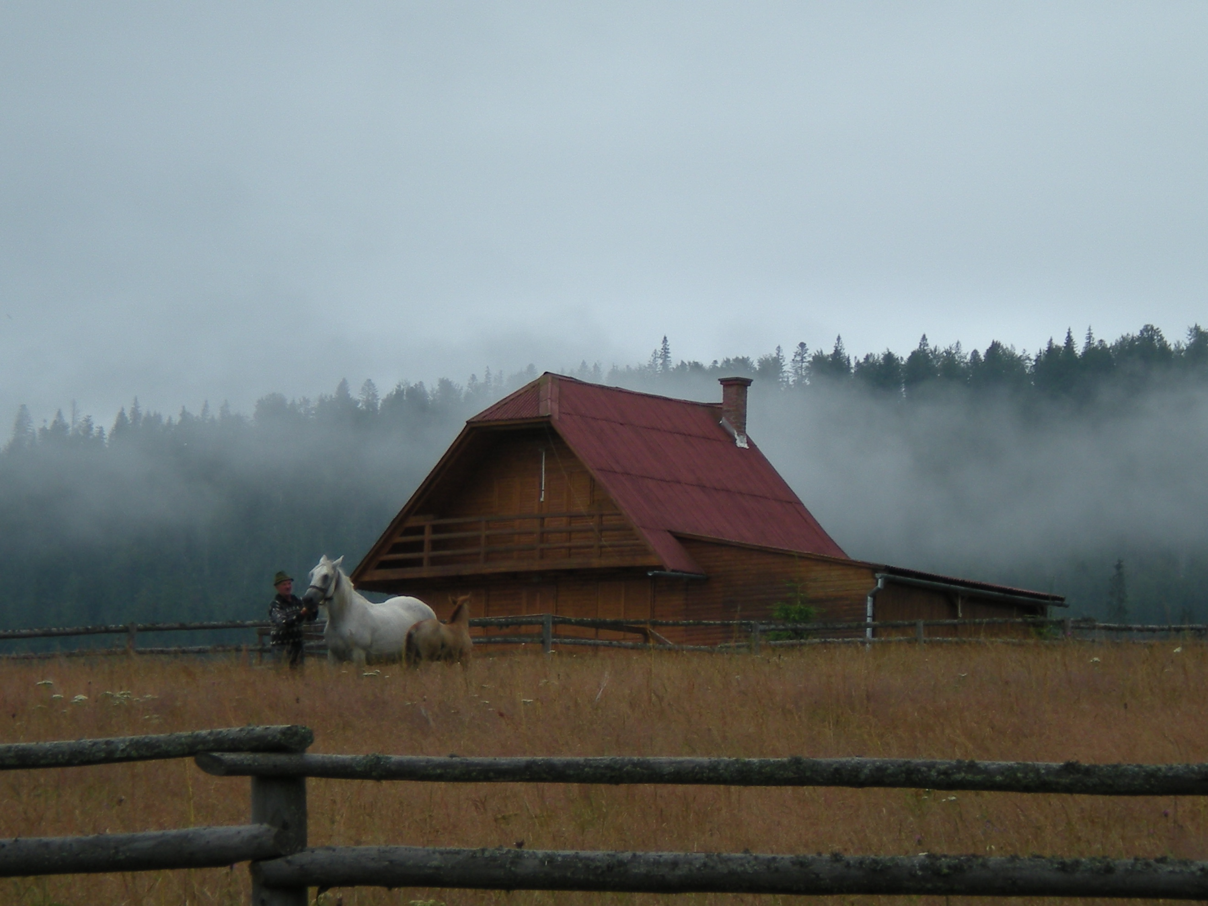

   Figure 1. Morning in the Apuseni Region. Credit: James Gruber

   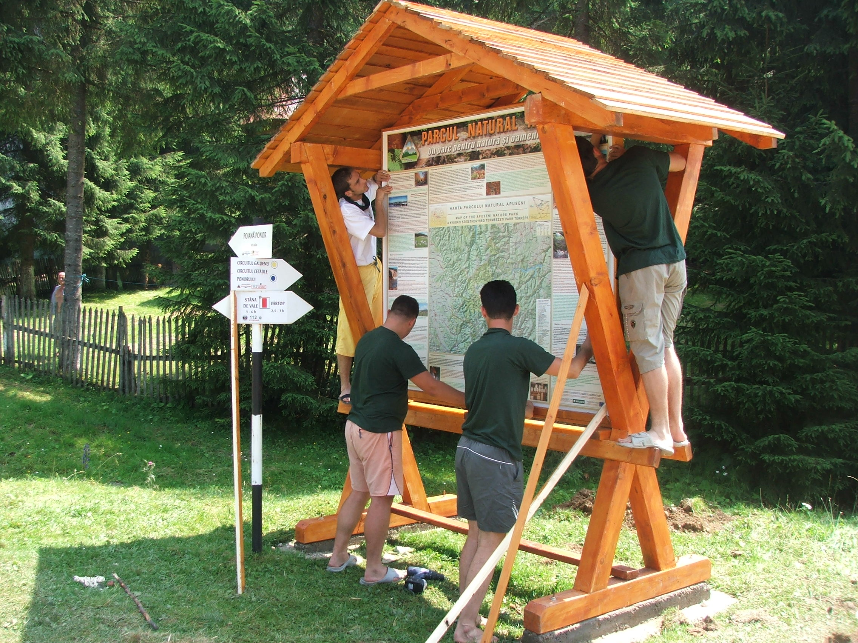

   Figure 2. Community Members Building Tourist Kiosk with Conservation Information. Credit: CET