Chapter 4 Principle C - Resources and Equity
Principle C: Resources and Equity
  - Environmental justice is a social imperative that includes recognizing local values.
  - Seek to improve (or minimize negative effects upon) the local economy.
  - Recognize need for linkages between conservation and local economy based upon equity, local needs, financial and environmental sustainability.
  - Seek equitable and fair distribution of local benefits, potentially including compensation for protecting natural resources.
  - Regulated access to natural resources and graduated sanctions can help ensure equity.

Review of Principle Key Components

(Needs 2 to 4 pages of text)

Local community sustainability, including natural resource conservation, requires the recognition of the needs for local livelihoods of its members. Effective sustainability practices should be able to both enhance the ecological resources that a community depends upon and meet the economic needs of all its residents. This may require thinking and planning with a longer time frame than is typical in many local communities today. It will also require addressing equity...where some have far more resources than they need, and others do not have enough to survive.

Equity issues with many local indigenous and minority communities in the US has a long history of un-fair treatment and oppression. This is also the case in many other parts of the world.
Academic researchers have found that for local communities to sustainably manage their ecological resources, support the local economy and embrace social vitality there needs to be clear linkages between natural resource protection and conservation, the recognition of local social values, and the economic needs and livelihoods of the community members This linkage should take into consideration equity, local needs, and sustainability. In order to promote equity, local natural resource dependent communities should seek the fair distribution of benefits as well as the sharing of hardships or challenges for those who may be subject to limited access to resources and/or sanctions⁴

Communal Forest, Ixtlán de Juárez, Oaxaca, Mexico
Case Study: with primary focus on Principle C: Resources and Equity
J. Gruber with F. Reyes
1. Introduction
One early spring in Montreal, Canada, at a meeting of the North America Council for Environmental Management, I heard about Ixtlán de Juárez, a “mile-high” forest community in the Oaxaca region of Mexico. This local indigenous Zapotec community, started in the 15th century, was turning around decades of national government driven ecological, economic, and social exploitations and was now recognized as a successful model of community-based resource management. My new colleague, Francis (Paco) Reyes, a lawyer and previous manager of the Forest Commission for the States of Oaxaca and Guerrero, offered to help organize and host my visit and to serve as my interpreter. My quest was to understand how, in a few decades, this change occurred. What was their approach, what strategies did they use, and how are these strategies related to the key principles of community-based resource management and sustainable development? I was not disappointed!
- General overview and initial presenting situation
That November, I arrived in Oaxaca, at the peak of the Day of the Dead (Dia de Muertos), a holiday celebrated by people of Mexican and indigenous heritage in honor of those that have died and to support their future spiritual journey. This rich cultural experience was a precursor to the coming days I spent in the Ixtlán high forest region with this vibrant Zapotec community.
The following day, Paco and I drove nearly two hours up the winding mountain road, passing by a recently established military base for combating the growing drug trade, and finally arrived at Ixtlán de Juárez. After meeting with C. Luis Pacheco Rodriguez, the community president, I had an opportunity to view and read about the last 50 or more years of rich history that adorned the wall of his office. Hanging on the wall behind his desk was the award by the World Wildlife Fund's (WWF) "Gift to the Earth" for the sustainable management of their forest. Pictures of generations of community leaders encircled the walls. Newspaper clippings of their numerous successful initiatives were framed. This was an active and engaged community that had struggled since the early 1980s to turn around previous exploitive actions from the national governmental, actions that were causing ecological, economic, and cultural harm to this indigenous forest community. Although this town is located in Oaxaca, one of the poorest states of Mexico, the local economy of Ixtlán is vibrant and growing with an emphasis on social, gender, as well as economic equity. It was reported that the average income of the residents this community is roughly twice the average of others living in the greater region.
The Town of Ixtlán de Juárez at 2,030 meters elevation with a current population of about 2,500 was founded in the latter half of the 15th century by the indigenous Zapotec people (Figure 4.1). By the mid 1940’s the forest in this region were subject to exploitation of timber from the private the paper mills Tuxtepec. Intensive land and forest exploitation were in full swing by the mid-1950s when the federal government pushed to establish a timber industry in the region by providing a 25-years concession (contract) to a state controlled company, Fapatux. Their actions during these 25 years resulted in serious exploitation and degradation of the forest in this Sierra Juárez region from 1956-1981⁸. This also led to wide-spread poverty and social-injustice. Starting in the early 1980’s major protests and resistance to the national government authority and these national contracts eventually resulted in transfer of control of this land to the local communities in 1986, including the Town of Ixtlán de Juárez. This was the dawn of a new local community, community-driven approach, for land management and conservation.
Figure 4.1 Aerial View and Location Map of Ixtlán (Source: http://www.noalamina.org/mineria-argentina-articulo862.html)
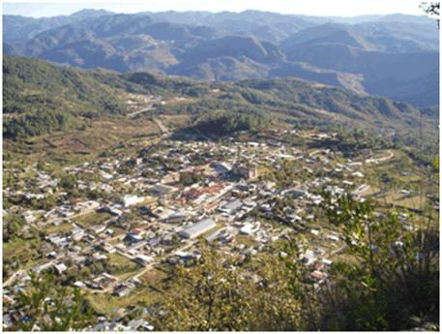
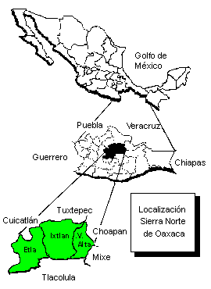
- Goals, approach, and challenges (with Key Principles shown as a letter(s) in parenthesis)
We had an opportunity over the next few days to conduct personal interviews and survey community leaders and residents. We asked about their goals, approach, and challenges or barriers they encountered along the way.

They described the goals of their community as;
- Managing the forest with sustainable management and harvesting practices,
- Developing alternative sustainable economic activities to replace the short-term reduction in revenues from the previous exploitative forest practices,
- Continuing to reduce pollution and environmentally damaging activities in their forest and on their land, and
- Appropriately managing sensitive ecological areas within their land.

Their overall approach has as a core the raising of the knowledge and skill levels of the members of the community (D). They expressed the importance of community members gaining a better understanding of their ecological systems and gaining the requisite knowledge and skills for effectively managing these resources.

In order to achieve this major paradigm or mind shift, one participant stated that they needed “to gain confidence/trust of the people/persons who had previously bad experiences from other government agencies (A & G).” Terms such as “building a sense of credibility”, “approval”, “acceptance of the project”, and “support/approval by the community” (B, F, & G) were woven throughout their responses to this question. Clearly, the credibility, trust, and confidence in their community leaders (I) were central to being able to facilitate this change process.

A number of individuals stated that the acceptance of the project by the local community members was dependent upon linking the conservation of their natural resources with future sustainable economic and social growth (C). They also stressed the importance of educating the community members so that they could gain an understanding of the importance and value of their natural resources (D). They emphasized that this change process required a gradual approach with trainings and hard work for all of those involved (A).

The community leaders stressed the importance of organization systems and social norms and values. The community’s organizational systems that they mentioned included: how the community was organized, including their participatory decision-making process (J), The (policy making) committee’s organizational structure (I), the project’s (furniture manufacturing) industrial structure (I), and their internal organization, regulations, and evaluations (H & I). The responses that are associated with the community’s social norms and values were: the high level of honesty and responsibility (G), community values like honesty and equity (C), and the confidence and trust in the leadership by the community members (G).

When asking these individuals the question “What was the most difficult barrier/challenge that the community had to overcome?” the responses primarily focused on the difficulty of initiating and carrying forward a community-wide change process. The challenges that they described included issues of sustainability, adaptive leadership, and an adaptive capacity change process (I & J). Clearly, the local community had complex social and ecological conditions and their leaders had to develop innovative solutions without a clear template or guide. One individual interviewed, when referring to the greatest challenge, stated it was “not knowing or “the unknown.”
4. Outcomes
This community and their communal forest (19,310 hectares) today have an international reputation for its effective community-based conservation and sustainable development efforts with over the last 30 years of history⁹⁸ . It is high up in the Sierra Norte Mountains located in the north-eastern region of Oaxaca (Figure 4.1). The Sierra Norte highlands region is one of the best-preserved biospheres in Mexico This region, dominated by humid pine and oak forests, is home to hundreds of bird species and thousands of plant species. The lumber that is now sustainably harvested is certified by the Forest Stewardship Council (FSC) and the European equivalent (PEFC). Ixtlán established a modern and well-equipped on-site furniture factory that manufactures “green” certified local wood furniture. The community has also established an eco-tourism program that includes lodges, a dining facility, trail systems, and related amenities. During the last 30 years they have established an international reputation for sustainable and green-certified forestry practices and as a centre for eco-tourism.
During my visit I noted that there was a broad and deep dedication by the community members to have a successful community-driven approach. The changes to date included a major shift from the previous, non-sustainable extraction of logs from the forests to a new sustainable approach that included eco-tourism, generating and replanting seedlings, green-certified forest management/harvesting, and developing value-added final products such as their “green-certified” furniture. This community is beginning to look outwards, towards tourists and customers for their green-certified furniture. They are also growing in their awareness of the global competition that they were competing for visitors…a small niche of the global market. Although there is a growing awareness that they have made major strides forward, they are also now aware of how much further they may need to go to achieve a sustainable natural resource-based economy. Two specific priorities they described include enhancing the quality of their wood products and becoming more sophisticated in the eco- tourism trade. Finally, they are aware of a growing impatience by some members of the community for raising the current living standard rather than the current priority of investing in their future.
“The Community of Ixtlán de Juárez has learned not only to manage their resources; (they) have found that if you unite and organize their efforts, the realization of its objectives will be achieved sooner or later.” (Jesus Alberto Belmonte, during the opening of the furniture plant, National Forest Commission)

I provide two brief examples are given to illustrate their specific actions taken towards achieving their goals.

Example A: From a Forestry Nursery to Producing Green-Certified Furniture

Over a period of 20 years, the previous non-sustainable forest harvesting practices were converted through an integrated systems approach. This systems approach included: 1) establishing and operating a tree nursery and tree planting, 2) limiting cutting and sustainably managing their forest, and 3) manufacturing and selling “green certified” furniture. This shifted their economic base from exploitive raw resource extraction (selling logs) to producing and selling a value-added product (wood furniture).

During the 1990’s the Ixtlán de Juárez forest commune worked towards certification of their woods by the Forest Stewardship Council (FSC) and the Pan European Forest Certification organization (PERC). These certifying organizations examine environmental, economic, and social factors for sustainably managing forests. The community was able to acquire FSC “green” forest certification for 15,750 ha out of the total of 19,310 ha that they control.

They established a local band sawmill, a kiln wood dryer, and a modern furniture factory that would use the newly certified “green” lumber (Figure 4.2). Consequently, all of their manufactured furniture is FSC certified. The manufactured products they produce include doors, desks, chairs, windows, books shelves and related school and office furniture. These are sold primarily to schools and to the government. This strategy of manufacturing and selling value-added “green” certified wood products has been successful with sales increasing. The young, 26 years old, manager of this furniture factory impressed me during our interview with his high level of dedication along with his entrepreneurial mind set. Enhancing the quality of their wood products is a high priority that is linked to working cooperatively and raising the level of knowledge and skills of all of the workers. He communicated this point by stating: “The most important, without doubt, is the people. The machines can be rented, selected, but if we don’t train and attend to the people, the work won’t get done or completed.” (Principle H)

Another initiative, established in 2006, is the Regional Forestry Nursery. In a partnership between the state government of Oaxaca and Ixtlán de Juárez, this automated high-tech nursery produces 500,000 trees a year for addressing the previous deforestation of approximately 2 million ha in the State of Oaxaca.The initial capital costs were supported by international donors. The nursery samplings are used for the restoration of ecosystems and commercial tree plantations.

Example B: Eco-Tourism – Competing on a Global Scale
“Good planning realizes that the natural and cultural resources are the foundation of Ecotourism.” (Manager of Eco-Tourism)

Eco-tourism was initiated in 1996 as a core component of an integrated program to sustainably manage their forest. The Sierra Norte highlands region has unique ecological assets and has been recognized as a well-preserved biosphere. The Ixtlán region also has an international reputation as a unique indigenous community. This may be due in part from the internally well-known book Journey to Ixtlán by Carlos Castaneda. Today, this eco-tourism program is well established with housing, dining facilities, trails, a training center, and guided tours on the flora and fauna (Figure 4.2). The Eco-tourism program is designed to protect the unique biodiversity of this humid pine and oak forested region. It supports conservation and preservation as well as providing a means to generate income in a sustainable manner. A participant who was active in developing the eco-tourism program shared the importance of raising the awareness and understanding by all community members. He advised: “Walk with the community and explain to them the potential that ecotourism would bring.” (Principle J)

Figure 4.2 Green Certified Lumber Furniture Factory and Eco-Tourism Lodge
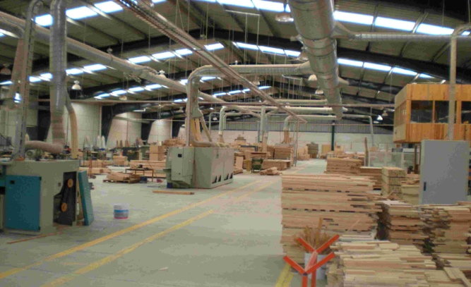
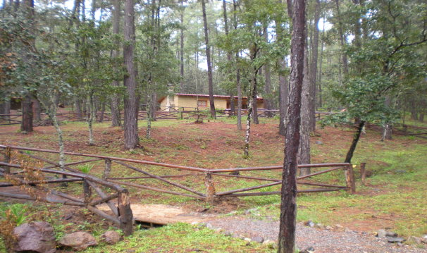
I was inspired by a statement from a senior member of the community as we closed our interview by stating: “We are a successful community because the community’s participation, the common grounds, and the conservation of our natural resources and environment for future generations.”

- Reflections on Principle C and this Case Study

This case study illustrates all 12 principles, some to greater extent than others. I will only focus on how Principle C: Resources and Equity can be illustrated by this case.
This indigenous local community had been economically and socially repressed and marginalized for many years by the Mexican national government and wealthy industrialists. During this dark period, the natural resources that were the economic foundation of this Zapotec community, were exploited and removed by these with external powers, a clear example of environmental in-justice. Only after, what some locally referred to as a local revolution, could they regain control over their community and the ecological systems that supports it. Rather than privatize the land, it was decided that nearly all the land would be managed as a “commons” or “common-pool-resource” for the community members immediate and future needs. The resulting actions turned around the previous years of environmental in-justice and built a new future for all residents of Ixtlán de Juárez where the sustainable yield of natural resources would be equitably shared. Equity also includes gender equity as stated by National Forest Commission “Ixtlán is not only an example of caring for the ecosystem and sustainable development, (but) also provides a broad view of gender equity.”
Their economy has also be gradually, but continuously, improving through preserving their forests (or natural capital) through thoughtful co-management of these resources. An early step in this process of change was recognizing the linkage between conservation and their local economy. A senior member of this community stated that one of the most difficult early challenges that had to be overcome was “Gaining the community’s openness and acceptance of the project as one of sustainability with economic and social growth and the conservation of resources.” Convincing the community members of this critical connection between: strengthening conservation; social vitality; and economic livelihoods was essential for building towards a sustainable future.

The community also decided to regulate access (limit all forest cutting) to protect certain critical natural resource areas. This protected their water supply as well as critical habitat of the flora and fauna. In order to have these areas support the economic needs of the community, eco-tourist was established that has provided local employment and income to the full community.

In order to limit the forest harvesting to a more sustainable level, the community built and now operates a wood furniture factory that produces value-added products. These products are sold to schools, other governments, and furnish their eco-tourism cabins. This enhances the economic return and reduces the harvesting of natural resources.

In closing, I believe that their embrace of Principle C: Resources and Equity, helped provide a moral compass that was seminar in building a strong community that could work together, face everyday challenges, and together, make the hard decisions that may be needed for a community to thrive.

Meinzen-Dick, R. & A. Knox. (1999). Collective Action, Property Rights, and Devolution of Natural Resource Management: A Conceptual Framework. Workshop: 2020 Vision Initiative. International Food Policy and Research Institute.
Leach, M., R. Mearns, & I. Scoones. (1999). Environmental Entitlements: Dynamics and Institutions in Community-Based Natural Resource Management. World Development 27:225-247.
Brown J, Mitchell N, Beresford M (eds) (2005) The protected landscape approach: linking nature, culture, and community. IUCN–The World Conservation Union, Gland, Switzerland, and Cambridge, UK
Spiteri, A. and S. K. Nepal. 2006. Incentive-Based Conservation programs in Developing Countries: A Review of Some Key Issues and Suggestions for Improvements. Environmental Management 37:1-14.
Hackel, J. D. 1999. Community Conservation and the Future of Africa’s Wildlife. Conservation Biology 13:726-734.
Barker, A. 2005. Capacity Building for Sustainability: Towards Community Development in Coastal Scotland. Journal of Environmental Management 75:11-19.
Anderies, J. M., M. A. Janssen, and E. Ostrom. 2004. A framework to analyze the robustness of social-ecological systems from an institutional perspective. Ecology and Society 9(1): 18. [online] URL: http://www.ecologyandsociety.org/vol9/iss1/art18/
Mexico Forest – Electron Journal of the National Forest Commission. Retrieved from: http://www.conafor.gob.mx Accessed March 17, 2009.
Asbjornsen , H. & Ashton, M. (2002). Community forestry in Oaxaca, Mexico., Journal of Sustainable Forestry, Vol. 15 Issue 1
Kansas University, www.ku.edu/ixtlandejuarez, accessed 2009
Unidad Comunal Forestal Agropecuaria Y De Servicios, 2008, Community Brochures of Ixtlán de Juárez, Oaxaca, Mexico

