Draft 1-27-1

Case Study: Wetlands Conservation and Sustainable Livelihoods in the Ecuadorian Andes
Case Study: with primary focus on Principle E: Promote Research and
Information Development
Fausto Lopez with Ramiro Morocho, Diana Astudillo, Sandra Pinel, and James Gruber
Prologue
High in the Southern Andes of Ecuador is a major wetland that provides critical water resources to adjacent local communities on the Pacific and the Amazon sides of the continental divide. Visitors to this remote region are amazed by the verdant green hills and mountains and the pristine lagoons, and peatlands. The un-disturbed ecology, the vulnerable and endangered species that inhabit this region, and the exceptional water resources directly impacts the livelihoods and culture of residents including the Saraguro, Shuar, and Mestiza people who have lived in this wetlands region for generations. However, concerns from recent and potential mining claims coupled withroad construction raised concerns that adverse or inappropriate uses could seriously impact this critical and fragile ecological habitat, the water resources, and negatively impact the future livelihoods of nearby local communities.

A local university, Universidad Técnica Particular de Loja (UTPL), recognized these ecological values, potential threats, and the importance on future conservation planning. UTPL has been collaboratively working with these local communities for over ten years to find a shared approach that will protect and preserve this critical wetland, and support the livelihoods, social health and vitality of these communities. Recently all of the local communities were able to reach a consensus by agreeing to protect this wetland region through the international Ramsar
Convention program. This case study also illustrates how UTPL approached their research role with these diverse local communities. This regional effort

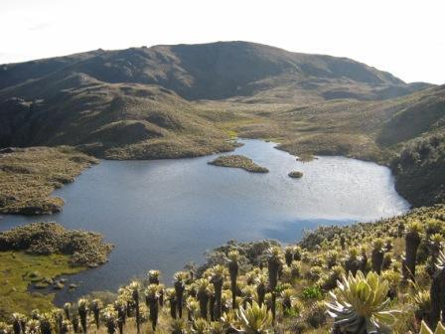
Figure 6.1 Wetland Region on the continental divide in the high Southern Andes. Photo Credit: S. Pinel

has raised knowledge and understanding of the critical ecological systems and grown the social capital and trust across local cultural and indigenous groups. At the end of this case study I will share how it specifically illustrates Principle E: Promote Research and Information Development.
1. Introduction
This case study is about a regional community in Southern Ecuador that is made up of over- lapping communities that historically have not always communicated well or had different perspectives on how to best serve their members. It includes the indigenous communities of Saraguro, Shuar, and Mestiza people and more recently the Nabón people; three local governments; supportive NGOs; the local Universidad Técnica Particular de Loja (UPTL) and international partners (University of Iowa and Antioch University New England). Starting in 2010, UTPL has been active in assisting these local communities and conducting studies on the natural-ecological systems of this wetland region as well as social and cultural research within the region. UTPL also provided direct assistance for community development and environmental education through NGOs. Their research is published and available in a number of journal articles. The research team and their partners completed a milestone event in 2015 by designing and convening a community-based process that included two regional participatory workshops with the local people, local government officials, and other stakeholders. This event provided a forum for the sharing of the previous years of social and ecological research as well as an opportunity to seek a shared vision and potential action steps for moving the community forward. This case will focus on this milestone event and the following actions during the last few years.
2. General overview and initial presenting situation (with Guiding Principles shown as a letter(s) in parenthesis)
Protection of this major Ecuadorian wetlands region in the southern high Andes is a significant concern to many indigenous groups in this region. This region, a prospective protected forest, can be considered by the International Union for Conservation of Nature (IUCN) as a Category-6 Landscape: Protected area with sustainable use of natural resources. These are critical ecological regions that are occupied by a rural community, typically an indigenous community.

To enhance societal outcomes from this research, the research team at UTPL decided to embrace the emerging methodology of Engaged Scholarship (also referred to as Community-Engaged Research and Community Based Participatory Research) to ground and strengthen this research and to enhance the likelihood of successful implementation of research outcomes (E). Engaged scholarship is a collaborative research and learning approach that works with multi-stakeholders and is suitable for studying multi-scale aquatic ecosystems and complex social-economic-and ecological systems (A). They conducted a range of research efforts that examined both the social, cultural, and ecological conditions in the field during a five-year period prior to convening these multi-stakeholder workshops. This allowed the UTPL project team members and their partners to build relationships with members of the three indigenous communities as well as with leaders of local governments, state institutions and NGOs in this region. This process strengthened the enabling conditions and the public trust and legitimacy of UTPL prior to the workshops (K & G). The project team also decided to draw upon prior research and published principles of effective Community-Based Natural Resource Management to both guide the participatory research process and to assess the process during the final workshops (A, E, & H).

Figure 6.2 Location Map of Oña- Saraguro-Yacuambi Wetlands. Credit: UTPL

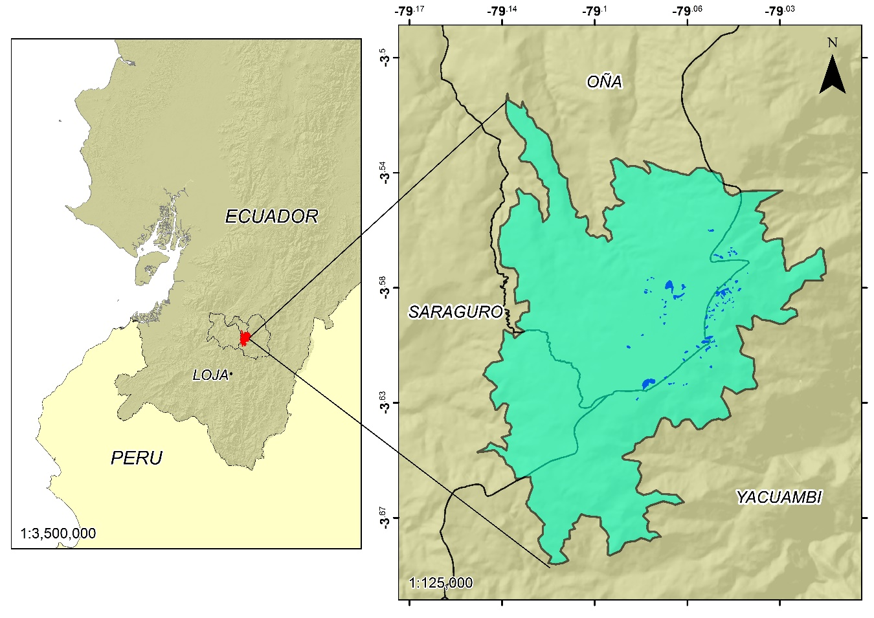
3. Goals, approach, and challenges (with Guiding Principles shown as a letter(s) in parenthesis)
The primary goal of this regional effort was to find common ground or consensus on how to conserve this critical wetland region in a manner that would also support the local social and livelihood needs of the indigenous people and local towns. This required a broad understanding of the ecological systems by the community members, including: how to protect the endangered species; and maintain the quantity/quality of the water from this wetland-- that is central to supporting the social and economic vitality of the region (D).

The second goal was to build bridging social capital and trust between the different indigenous and local government groups. This term “bridging social capital” refers to the growth of interpersonal relationships between individuals and groups that do not frequently associate. This building of social capital and trust started years before the workshops (B, G, & K).

The third goal was to determine if there was a broad enough understanding, sufficient support and commitment to future cooperation for seeking to have this critical wetlands region designated as Ramsar Wetlands (D, F, & L). Two regional workshops were designed and held based upon best-practices of collaborative multi-stakeholder processes(A, B, & J) to help achieve these three goals. These were held in the Yacuambi region (eastern side of the Andes) and in Oña -Saraguro region (western side of the Andes).

Figure 6.3 Loja, a local community in the Southern Andes watershed region Photo Credit: J. Gruber

These two multi-stakeholder workshops held in May 2015 focused on the feasibility of community-based and collaborative management for the future of the Saraguro- Oña -Yacuambi Wetlands. The workshop process was designed to share the natural science and social science research completed by UTPL over that previous five years and to seek a shared vision and approach as to how to move forward on preserving and protecting this major páramo wetland region (A, B, D, F, & J). The workshops were structured to provide an opportunity for local government leaders, national and other stakeholders to contribute ideas and resources to the conservation of this critical wetlands region. A primary objective of this workshop process was to ensure that the ecological concerns and the priorities of the local communities were well reflected in the future plan (C). It was recognized that different cultural communities might define conservation goals differently (C). UTPL and their partners wanted to ensure that “all voices” were heard and that any plan to move forward reflected and respected this diversity of perspectives (A, C, & E). The workshops also offered an opportunity to conduct an assessment of this community-based research project based upon published principles for successful community-based natural resource management efforts (H).

Both workshops were well attended and resulted in shared visions, prioritization of the concerns/problems of the region, and a framework of a strategic plan to move forward (A, D, F, J & L). This was done through small groups, report outs, discussions all designed to ensure that participants had a clear voice in prioritizing issues that were developed (Figure 6.4) (F, J, & K).
4. Outcomes
There are four shared overall outcomes from the two workshops that are based upon written feedback and follow-up discussions with the workshop coordinators. These are:
- A clear growth in social capital and trust between and among the stakeholders
- Broad support for moving towards a Ramsar Wetlands designation without conflicts between stakeholders involved in this major initiative.
- The recognition of remaining questions and concerns about how it would all work and ideas on developing a future management plan of this wetlands region.
- An increased level of awareness and commitment to work together, across both the western and eastern sides of the Andes.
Perhaps the most significant outcome of the workshops was that there was virtually no disagreement or concerns raised about moving towards a Ramsar Wetlands designation (J). As noted above, there were a number of unsolved questions about logistics in implementing this conservation initiative including the process for developing a management plan (I). However, equally important, there was an increased level of awareness and commitment to work together, across both the western and eastern sides of the Andes (A, B, & C). The positive energy was at times palatable among the participants.

Figure 6.4. Small Group working session at workshop Photo Credit: J. Gruber

Another outcome of the workshops included assessing “Future Management Approaches.” The strongest and broadest support was that “All three municipalities and its Parroquias- parishes (sub-regions) should conserve the (wetlands) area.” The least support was for “The Ministerio de Ambiente (National Environment Ministry) to be responsible for the (wetlands) area.” Local communities were ready to step up to collaboratively work together to manage and protect this critical natural resource (F, I & L).

The final outcomes from the workshops included conducting an assessment of the leadership approach that UTPL had adopted over five years ago when they initiated this effort (H). Three of the 12 Guiding Principles were assessed by all participants. These were: Principle B: Build Social Capital and Collaborative Partnerships; Principle E: Promote Research and Information Development; and Principle J: Enable and Support Participatory Decision-Making Processes. All participants rated the five key characteristics associated with each of these three principles on a scale from -3 (“least important”) to +3 (“most important”). Although there were a few negative rankings, the preponderance of rankings was positive with an average ranking for each of these three Principles of +2.47 or higher. It was clear that the approach stewarded by UTPL resonated with nearly all stakeholders and was instrumental with growing trust, knowledge, understanding, and support for moving together to conserve this wetland region through a collaborative approach (B, E, & J).

Figure 6.5: Local community members placing priority dots on a generated list of concerns and/or problems that needed to be addressed with conserving and managing this critical wetlands region. Location of workshops: Yacuambi and Zamora Chinchipe, Ecuador. Photo Credit: J. Gruber

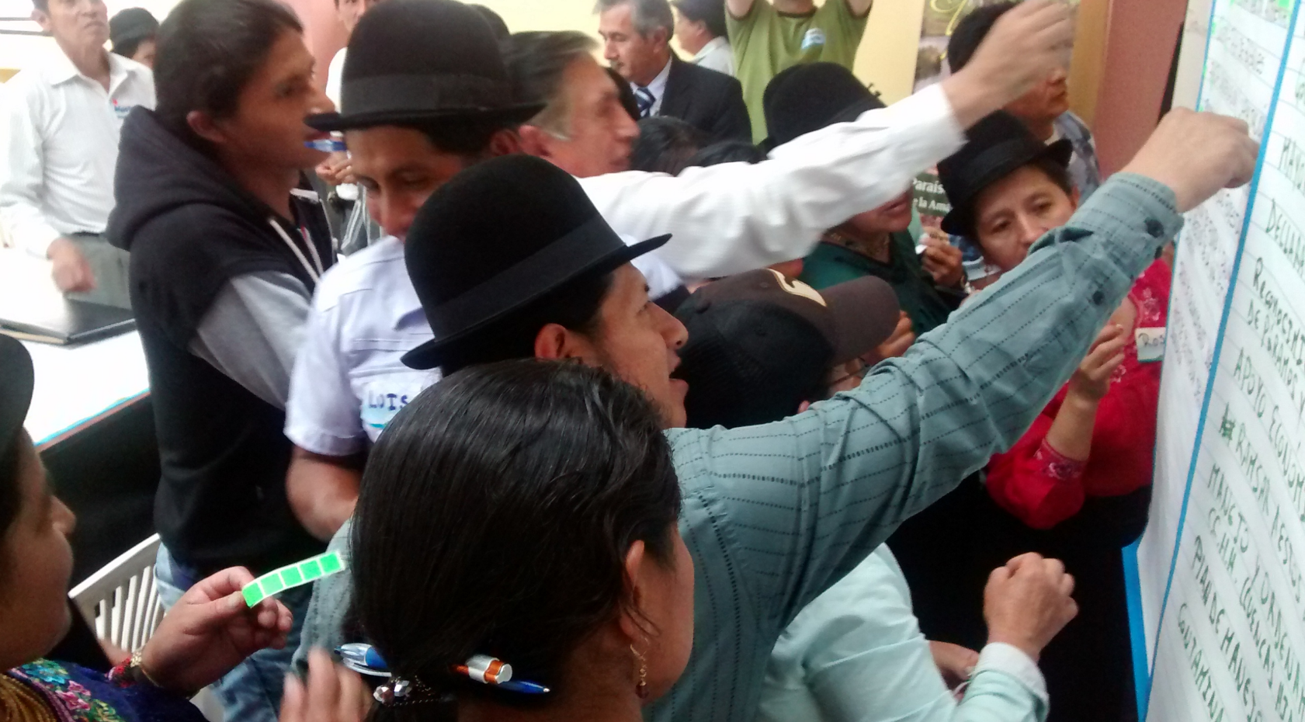

This research approach has allowed for UTPL to incorporate diverse perspectives on this complex social-ecological system from the earliest phase of the project (C). The process has allowed for effective data collection and feedback by those individuals who are most closely involved with this major wetland region. The research team at UTPL also anticipate that this engaged scholarship process will greatly magnify the broader impacts of the project by providing stakeholders with co-developed knowledge that they can use to explore the implications of their own management approaches and policies (A, C, & I). This engaged scholarship process has and, I believe, will continue to enhanced the legitimacy of governance solutions to this wetland conservation effort, increase social bonding capital and reduce future regulatory costs associated with long-term management (B, G, & L)

This case study illustrates how neighboring local communities, which include indigenous people and ethnic groups, can be successful in working together with a local university to find a common path that meets their future social, economic, and environmental vision for their region. However, a recent involvement by an Ecuadorian Government has recently delayed this process due to a previous mining concession near this region. However, due to the board support and trust earned thought the years of engagement of local stakeholders that included discussions, local workshops, consensus building and broad sharing of this proposal conservation proposal over a number of years, it is now likely that the Ministry will provide final formal approval in the very near future. Conservation and protection of this wetland will support long term sustainability and the vitality of this region. It is hoped that the board ownership, knowledge, and social capital that has grown within and between local communities during the past years will continue into the future.

Figure 6.6. The Southern High Andes Wetlands for consideration of Ramsar Conservation Designation Status. Photo Credit: UTPL
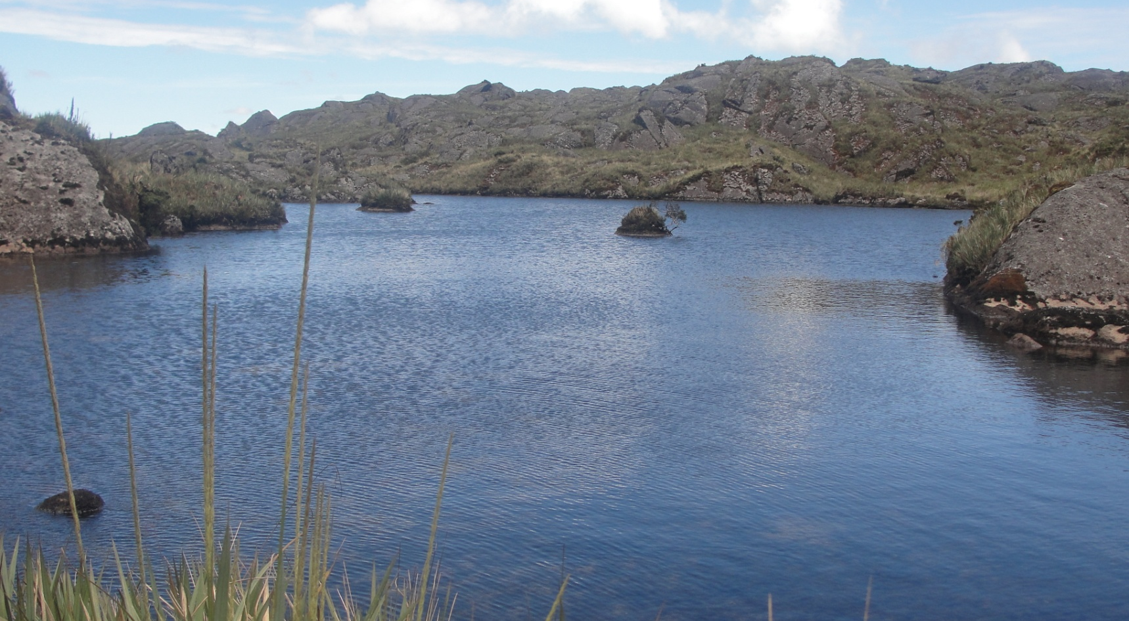

- Reflections on Principle E and this Case Study

This case study illustrates all 12 Guiding Principles. We will only focus below on how Principle E: Promote Research and Information Development is illustrated by this case study. The following five key components for Principle E that are:
- There is a common information base that is accessible and useful.
- Decisions should be based upon a broad but systematic body of information.
- Integrated information includes technical, scientific, social, quality-of-life, economic, and other forms of local knowledge including indigenous experiential knowledge.
- Economic evaluation of environmental assets is a valuable information base.
- On-going research is necessary to improve upon existing solutions including a role for community members in collection of scientific information.

The first three components were core to the research and informational efforts led by UTPL. Building a common base of shared information and promoting decisions based upon a broad base of knowledge directly linked to this wetland region was the foundation of the approach. Early on in the research, efforts were made to gather and analyze information on social, quality-of-life, economics, and other forms of local knowledge, including the experiences of local indigenous communities and Mestiza people of the Saraguro, Oña, and Yacuambi municipalities or cantons.

Leading a change process requires building a broad understanding of the critical issues and why change is needed. This required time and persistence for the local municipalities as well as the staff of the Ministry to understand why protecting this wetland is important to them today and for their future. This prior foundational work was critical before holding workshops in order to gain participation and engagement. The techniques that we used and found that were most effective with gathering local knowledge and information (and reaching consensus with stakeholders across our region) were participatory workshops and sharing technical information on ecology and social impacts of wetland through presentations and talks. These presentations needed to be accessible to lay persons, by being clear and by avoiding technical and scientific jargon. It is critical to “transform” technical lectures into simple language for people to understand. We also had to face the challenge of bringing people together, sometimes from significant distances from the wetlands, with limited transportation options and financial resources. Facilitation techniques during the workshops were also important. Workshop agendas were designed to encourage involvement of local stakeholders in giving feedback, sharing their ideas, and providing their priorities.

This engaged scholarship process has and, we believe, will continue to enhance the legitimacy of governance solutions to this wetlands regional conservation effort, increase the positive connections and relationships across this region, and reduce future regulatory costs associated with long-term conservation and management. It should also preserve this critical water resource along with the ecological services that the wetlands provide. In the future, conducting economic evaluations on these wetlands conservation strategies (including both costs and the economic values of ecological services) could be beneficial. Continuing the research as conditions change will yield new information that will be valuable. Ideally, establishing an on-going role for community members will both enhance knowledge, ownership, and commitment to the long-term stewardship of this critical wetlands resource.

We hope that this participatory, community-based planning process and applied engaged scholarship research may also be a model for university-community engaged scholarship research for other wetland conservation initiative. Conserving critical ecological resources through a collaborative process with all community members is a foundation for building a healthy, vibrant, and sustainable community.

*****************
Endnotes

Published information and journal articles that describe the social and ecological research include: Universidad Técnica Particular de Loja (UTPL). Memorias del Taller “Trabajando juntos para la conservación de los páramos y lagunas de Oña, Saraguro y Yacuambi”. Proyecto descentralización y gestión de la conservación: un análisis de las decisiones que afectan a los humedales altoandinos y páramos de Oña, Saraguro y Yacuambi Sandra Lee Pinel, Fausto López Rodriguez, Ramiro Morocho Cuenca, Diana Astudillo Aguillar & Danie Merriman (2018): Scaling down or scaling up? Local actor decisions and the feasibility of decentralized environmental governance: a case of Páramo wetlands in Southern Ecuador, Scottish Geographical Journal, DOI: 10.1080/14702541.2018.1439522 Iñiguez, M., J. Helsley, S. Pinel, J. Ammon, F. López and K. Wendland. 2013. Collaborative Community-based Governance in a Transboundary Wetland System in the Ecuadorian Andes.
Forsgren, A., Pinel, S. López-Rodríguez, F., Morocho Cuenca, R. , The Social and Cultural Importance of High Andean Wetlands: Addressing the Stewardship Approach for Wetland Management, The International Journal of Social Sustainability in Economic, Social, and Cultural Context, Vol. 10, 2015 www.onsustainability.com
State institutions include: SENAGUA, SENPLADES, MAE
Agrawal, A. and C. C. Gibson. 1999. Enchantment and Disenchantment: The Role of the Community in Natural Resource Conservation. World Development 27:629-649; Anderies, J. M., M. A. Janssen, and E. Ostrom. 2004. A framework to analyze the robustness of social-ecological systems from an institutional perspective. Ecology and Society 9(1): 18.; Armitage, D. 2005. Adaptive Capacity and Community-Based Natural Resource Management. Environmental Management 35:703-715.; Gruber J. S., Key Principles of Community-Based Natural Resource Management: A synthesis and interpretation of identified effective approaches for managing the commons, J. Environmental Management, 2008.
Gruber J. S., Rhoades J. L., Simpson M., Stack, L, Yetka L., Wood R. Enhancing Climate Change Adaptation: Strategies for community engagement and university-community partnerships. J Environmental Studies and Science, 2015.
Gruber J. S., Key Principles of Community-Based Natural Resource Management: A synthesis and interpretation of identified effective approaches for managing the commons, J. Environmental Management, 2008.
Olsson et al. 2007

