Word Count 3020
Reclaiming Neighborhoods, Resources, and Lives in Baltimore, Maryland, USA
S. Hines, N. Srinivasan, L. Marshall & J.M. Grove
Adapted by J. Kenfack Kenjio
Prologue
This case presents a “multi-faceted approach to solving the complex problems of inner-city vacant homes and unemployment and the need to protect forests in an age of climate change and can serve as a model for other cities.” In Baltimore, a city with thousands of vacant and abandoned homes, reclaiming wood, bricks, and other valuable materials through de-construction has been proven to “help remedy problems related to blight and unemployment and contribute to neighborhood revitalization.” This successful community-wide effort to increase environmental, economic, and social benefits, as well as sustainability and resilience, relied on the willingness of a team of partners to face large-scale challenges while engaging in collaborative problem solving. It not only succeeded in recovering valuable and re-useable resources but also resulted in a positive systemic change that improved the lives of local citizens. This case draws upon an interview with key a stakeholder as well as published accounts of this initiative.
1. Introduction
It’s not a well-kept secret that Baltimore has its fair share of challenges. Hard-hit by suburbanization and a loss of manufacturing jobs after World War II, the city has lost over a third of its peak population. This loss has exacerbated economic stagnation and racial segregation, raising the need for creative revitalization. I first visited Baltimore in 2017, and what I saw left an indelible mark in me. Entire blocks of rowhomes that must have been bustling with people and activities a few decades earlier, now stood empty along with vacant storefronts and businesses. I saw people (mostly African Americans) roaming scanty streets soliciting and exchanging what appeared to be recreational drugs. This experience made me wonder two things: how did this city come to this state? and what was been done to address these problems?
It’s within this urban landscape that the US Forest Service and a diverse group of community partners are piloting an effective approach that appears to address many of these problems simultaneously. This creative integrated approach to urban renewal focuses on the reclamation and innovative re-use of wood and bricks. Recognizing that many post-industrial cities face challenges similar to Baltimore’s, the community partners feel that because of their on-going success with this urban revitalization initiative, there is potential to replicate their approach in other stressed urban areas with similar challenges.

2. General Overview and Initial Presentation of Situation
The city of Baltimore, established in 1730, is one of the oldest cities in the United States. Baltimore’s rapid development in the 18th century was primarily ignited by the industrial revolution and commercial trading. The growth of industries resulted in the extensive demand for labor. This demand for labor resulted in the influx of immigrants and slaves from different parts of the world such as Acadia, Ireland, Santo Domingo (today Haiti), Italy and Poland². Over the course of that same 18th century, Baltimore became the second major port of entry into the U.S. (after New York City) following the arrival of over two million immigrants through Baltimore’s harbor². In 1820, Baltimore had the largest population of African Americans in the Unites States, most of whom were slaves. During and after the Second World War, Baltimore’s manufacturing sector exploded as the city benefitted from the introduction of factories that produced and tested military equipment like planes, ships, tanks and automobiles². This explosion was also followed by a large increase in the population of the city—especially the African-American population. Housing shortages therefore became critical as the incentives and demand for suburban housing was exclusive to a certain group of privileged people. African-Americans were systematically denied access to privileged suburban neighborhoods through the process of Redlining. This discriminatory practice resulted in racially and economically divided neighborhoods.
Figure 4.1: Abandoned Rowhomes in Baltimore
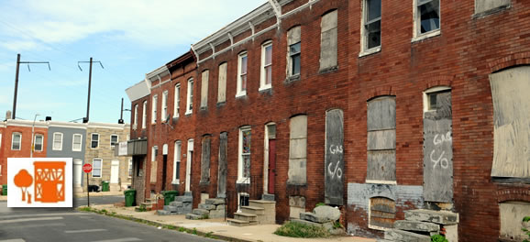
The more recent problem of neighborhood vacancy can be traced back to the loss of manufacturing after the 1950’s and to discriminatory housing practices and racial segregation. Today with the continuous urban depopulation, Baltimore, which was home to over 950,000 people in the 1950s, now only provides a home to approximately 615,000 residents².
3. Goals, Approach, and Challenges (with Key Principles shown as a letter(s) in parenthesis)
While the U.S. has very few old growth forests remaining and, therefore, it is generally not desirable to harvest those that remain, there is still an abundance of old growth wood available for use - it just happens to be locked up in Baltimore’s many abandoned rowhomes (Figure 1).
Wood accounts for more than ten percent of the annual waste material in the U.S. Out of the 70.6 million tons of wood waste generated in 2010, 42% comes from demolition activities². Trees from urban forestry operations, especially those that have sustained damage from pests or infections, also produce considerable amounts of waste. Much of this can be reclaimed, making the recovery of this wood a major opportunity for addressing triple bottom line issues. According to research done by the U.S. Forest Service, reclaiming the wood from the national waste stream could replace the need of 30% of the annual consumption of hardwood trees in the U.S. Diverting wood from the waste stream preserves valuable material and prevents it from taking up space in already-overflowing landfills (C & K).
The United States Forest Service (USFS) championed the urban wood reclamation initiative in Baltimore. Rather than a simple approach of demolition and recovery, the Forest Service choose to work closely with organizations and members of the community to co-create a transformative process that could directly benefit the community as well as recover natural resources. These leaders in Baltimore support “knowledge co-production”, which involves researchers working together with communities, stakeholders, and practitioners to produce actionable knowledge (E, A). This co-production of knowledge approach led to the establishment of partnerships with multiple stakeholders (Table 4.1).
The multifaceted approach to Baltimore’s complex problems relied on holistic goals:
- Creating livelihoods, improving lives for minority population in their neighborhoods
- Supporting the US wood processing and manufacturing industry
- Enabling ecological restoration
- Serving as a model for creating a circular, self-reinforcing economy in urban areas
It was also hoped that by achieving these four goals, through an inclusive, multi-stakeholder effort, growing this effort in the future could be supported by attracting much-needed private investment and economic development for the city (C).
Table 4.1 List of Key Partners and Their Roles in the Baltimore Urban Revitalization Initiative

Key Partners | Mission | Role Played in this Initiative
United States Department of Agriculture, Forest Services | This federal agency manages and protects US national forests and grasslands. Their mission is to sustain the health, diversity, and productivity of the nation’s forests and grasslands to meet the needs of present and future generations. | Early champion of the urban wood initiative project and established partnerships. The USFS is currently leading two complimentary approaches: the identification of national buyers and the creation of access to capital.
Maryland Department of Housing and Community Development | They work with partners to finance housing opportunities and revitalize great places for Maryland citizens to live, work and prosper. | They partnered with Humanim Inc. on the idea of deconstruction with the goal of fighting urban blight caused from vacant houses.
Maryland Department of Natural Resources | Their mission includes preserving, protecting, restoring, and enhancing the State’s natural resources. | They provided support for the creation and management of community parks, urban forest assessments, and the diversion of de-construction waste from landfills.
Baltimore Office of Sustainability | Their mission is to strengthen its communities through collaborative social, environmental, and economic planning and action. | They partnered with Humanim's enterprise (Details Deconstruction) on the urban wood deconstruction initiative in an effort to create employment opportunities for residents, reduce the quantity of waste directed to landfills, and salvage materials for reuse.
Humanim Inc. | Humanim Inc. is multi-enterprise non-profit organization with a mission to support and empower individuals who face social or  economic challenges by building pathways to economic equity, opportunity, and independence | Through their different enterprises they were able to collaborate effectively with the USFS to sustainably remove the vacant homes. Details Deconstruction (a subsidiary) started hiring and training local residents suffering from high unemployment and incarceration rates to deconstruct vacant buildings. Once the buildings have been deconstructed, the salvageable materials are taken to Brick & Board to be processed, aggregated, refurbished, and sold.
Room & Board | A modern furniture and home décor retailer committed to sustainable practices and American craftsmanship that creates exclusive contemporary designs for modern living rooms, dining rooms, and bedrooms | Room & Board joined the project in 2017. Through their partnership with the USFS, they are repurposing the wood salvaged from the deconstructed houses into furniture, flooring, wall clouding and siding.
Camp Small | Camp Small is the city’s wood waste collection yard whose mission is to sort and distribute variety of wood products for the city. | Under the Camp Small Zero Waste initiative, this wood waste collection yard became a wood sorting, processing, and distribution site in Baltimore.
Parks and People Foundation | This non-profit organization transforms and restores the land following deconstruction into green spaces like parks and playing grounds. | They engage with communities to visualize designs for the land after deconstruction. They partnered with the USFS to engage with the Easterwood community in 2016 to design the Easterwood/Sandtown Park and Playground
Quantified Ventures | This is a social impact investment advisory firm that simplifies the process of financing innovative and evidence-based environmental, health, and educational outcomes. | Quantified Venture goal is to use social impact investment to scale up both the fresh cut and deconstructed urban wood.
The Multi-faceted Approach to Baltimore’s Vacancy Problem
The foundational approach toward solving Baltimore’s problem involved the creation of collaborative partnerships, knowledge co-production, open communication systems, and the establishment of strong support systems between different stakeholders (B, E, D, & A). Open communication loops between the different actors were vital in managing prevailing challenges (D, H). "Communications between the different partners were enhanced by in-person meetings, brainstorming ideas, and visiting deconstruction sites as a team"¹. The involvement of communities at different stages of the urban revitalization process not only ensured that the needs and desires of the residents were observed, but also fostered a sense of trust and stewardship among the residents (A, B, I, G, & F). For example, Parks & People engaged community members in the visualization of designs of the vacant lots after deconstruction.
The leadership team in this case study was formed through "... organic interest expressed by the different stakeholders in solving the Baltimore vacant home problem"¹. Collaborative partnerships involving stakeholders of diverse backgrounds and areas of specialties can create networks of problem-solving approaches that improve communities, solve presenting problems, and generate outstanding outcomes. “Creating partnerships with both private and public organizations was a viable way to remove these vacant homes “¹.
The major challenge identified by the proponents of this urban revitalization initiative in Baltimore was the decision to remove the vacant buildings by either demolition or deconstruction (L). Demolition had been the standard method for eradicating vacant buildings in Baltimore because it was quicker, cheaper, and less labor intensive. However, in 2012 when the urban wood project began, the deconstruction method was prioritized by the leaders because it was sustainable, created more jobs, and was more economically affordable when all factors were considered. Through deconstruction, up to 90 percent of the materials in a vacant building was repurposed, hence diverting waste from landfills, and preventing the exploitation of natural resources –including forest products (C). Multiple endorsements from different stakeholders facilitated the decision process (I).
There was wide support for proceeding with this innovative deconstruction approach because of the significant socio-economic and environmental benefits of implementation. This decision was not only favorable to the city of Baltimore, but also to the stakeholders involved in this broad partnership. For example, while Parks and People Foundation would need to spend $250,000 to build a park on land that had buildings demolished, it would only need to spend $50,000 on a cleaner site that had buildings deconstructed (C) ³. Moreover, “Deconstruction with its added need for labor, has the ability to ameliorate some of the difficulties citizens returning from prison face in finding jobs”³
4. Outcomes

In less than ten years of operation Baltimore’s multi-faceted revitalization initiative has been successful at multiple scales. The City of Baltimore, which originally had over 16,800 vacant homes, has removed “350 vacant homes through deconstruction since the beginning of the project in 2012”. ¹ The USFS and its partners, have devised a plan for significantly scaling-up the number of house units deconstructed to 250 buildings annually. This goal will generate more employment opportunities, salvage (recycle/reuse) more building materials, and transform more deteriorated row-house city blocks into healthy and vibrant neighborhoods.

Materials such as bricks and wood salvaged from deconstruction has been repurposed and re-sold bringing revenue to the city. Through Details Deconstruction and Brick & Board, Humanim Inc. has developed one of the largest markets in the U.S. for reclaimed brick from Baltimore.

The initiative has created jobs for Baltimore residents which has also helped reduce poverty levels, reduce high incarceration rates, and improved lives. “My wife and I have just bought a house...this is the first time I have owned anything that I can call mine, it came from working...I am living my best life right now”⁸ said a Baltimore resident and employee of Details Deconstruction. By 2018, after six years of operation, Details Deconstruction has trained and employed 165 low-income residents³. Multiple greenspaces, public, and recreational grounds (like parks) have been created which has improved the social vitality, wellbeing, safety, and happiness of the residents of Baltimore. “These parks are restorative which brings life to a community…contributes to a sense of wellbeing public health, watershed, beauty and a sense of tranquility” ⁸

Figure 4.4: Employees of Details Deconstruction and Brick & Board at Work

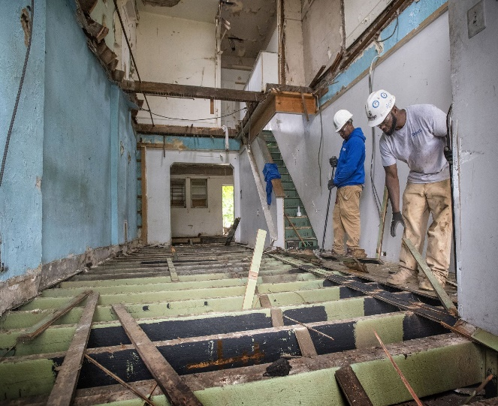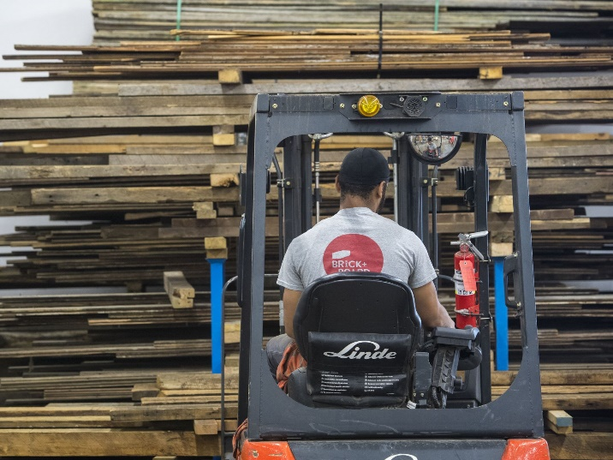

This community was able to transform some of their neighborhoods from an unsafe state of urban decay to a welcoming neighborhood with open green spaces, pocket parks, and maintained homes. Parks and People Foundation, constructed multiple parks and playgrounds including: the Sandtown Park and Playground, and the Harlem Park. In some instances, the lots left from deconstruction are “developed into new and affordable housing units for the residents of Baltimore”¹.

By 2018, Room & Board had launched almost a dozen products made of reclaimed yellow pine under the brand name: ‘Urban Wood Project: Baltimore’. Room & Board has also developed partnerships with local manufacturing companies like Open Works not only to produce furniture out of reclaimed pine, but also to create meaningful employment opportunities for those with employment barriers. Room & Board also financially supports the city through its donations to Parks and People Foundation for the creation and maintenance of parks and playgrounds.

5. Reflections on Principle C and this Case Study

My experience with the Baltimore community has taught me one lesson: successful measures to increase sustainability and resilience depend on the willingness of those involved to take-on large scale challenges and engage in collaborative thinking to produce innovative solutions.

This case study also demonstrates that addressing economic inequality and racism can go hand in hand with effective resource conservation. There are some valuable take away lessons to be learned from this community effort. During an interview with one of the community leaders in Baltimore, they said that: "it has been a very rewarding and powerful experience for all of us as a community...in order to solve complex problems one needs to think creatively and holistically...identify where the barriers are and work as a team to remove them. The federal government should embrace the role of a catalyst by creating ideal conditions for success at a community level.”¹ I personally believe that the ongoing urban revitalization initiative in Baltimore is one that depicts a brilliant example of a bottom-up, citizen empowerment approach to the addressing the urban blight.

In my view, the embrace of Principle C: Sustainably Manage Natural Resources and Promote Equitable Distribution of Benefits by the urban revitalization initiative in Baltimore has provided an excellent prototype for urban economies in other U.S. urban areas as well as world cities facing similar problems. The different stakeholders were able to sustainably manage the forest resources of Baltimore and effectively collaborate with one another in solving a complex urban problem, while building a strong and vibrant community. It is no surprise that this initiative received the Mutual of America Partnership Award in 2018. In an official statement, "Mutual of America proudly recognizes Humanim, Inc. and its partners for their pioneering work with Baltimore City Deconstruction Project, providing employment opportunities to underserved residents while reducing urban blight, reclaiming materials and increasing green spaces".⁸

I was fortunate to interview one of the community stakeholders (Sarah Hines) about this multi-dimensional urban development initiative. Sarah is a Science Delivery Specialist at the Baltimore Field Station for the US Forest Services, and was driectly involved in the urban wood initiative.
Hines, S., Srinivasan, N., Marshall, L. & Grove, M. L. (2017). Reclaiming wood, lives, and communities: How do we turn a waste stream into an asset that revitalizes cities?
Redlining was a common method used in the 20th century as a method to discriminate the African American population by denying federal mortgages in certain minority neighborhoods or communities. This practice started in Baltimore in the 1930s.
Falk, B. & McKeever, D. (2012, August). Generation and recovery of solid wood waste in the U.S. BioCycle, 53. Retrieved from https://www.biocycle.net/2012/08/15/generation-and-recovery-of-solid-wood-waste-in-the-u-s/
In the context of the urban revitalization initiative—and sustainable management of natural resources (wood, bricks etc.) in Baltimore, the application of the triple bottom line framework will help address both social, environmental and economic (financial) problems created by urban vacancy.
[see graph] Retrieved from: https://www.learngala.com/cases/urbanwood/3
Co-production ensured that concrete and practical research suits decisions makers
Duncan, I. (2018). In 2010 Baltimore had 16800 vacants. Eight years and millions of dollars later, the number is down to 16,500. Retrieved from: https://www.baltimoresun.com/news/maryland/baltimore-city/bs-md-ci-vacant-demolition-blocks-20180227-story.html
Sharif, D. (2018). Why we’re excited about bricks and boards. Retrieved from: https://www.quantifiedventures.com/bricks-and-boards.

